PART A:

I)

Vin=24V

Case 1: Ideal Case

parasitic resistance of inductor rl = 0

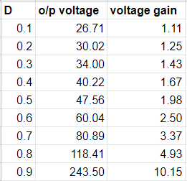

Case 2:

parasitic resistance of inductor rl = 5% of RL

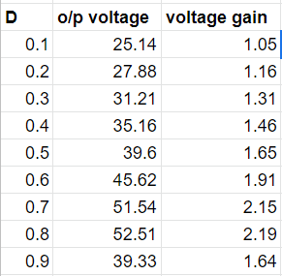

II)

D=0.5;

RMS Capacitor Current: 4.34 amp

III)

D=0.5;

Inductance = 14.4 uF

V)

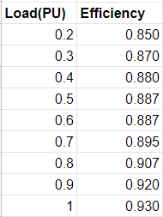

____________________________________________________________________________

PART B:

I)

Vin=57V

Case 1:

parasitic resistance of inductor rl = 0

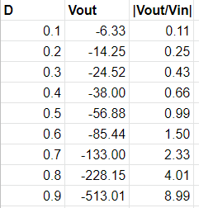

D=0.457 Fsw for which system in CCM and DCM

Fsw = 7.55 KHz

Case 2:

parasitic resistance of inductor rl = 5% of RL

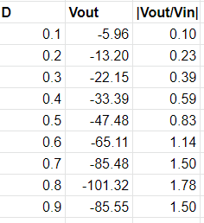

D=0.457 Fsw for which system in CCM and DCM

Fsw = 7.95 KHz

II)

calculation:

switching frequency = 13.8KHz is verge

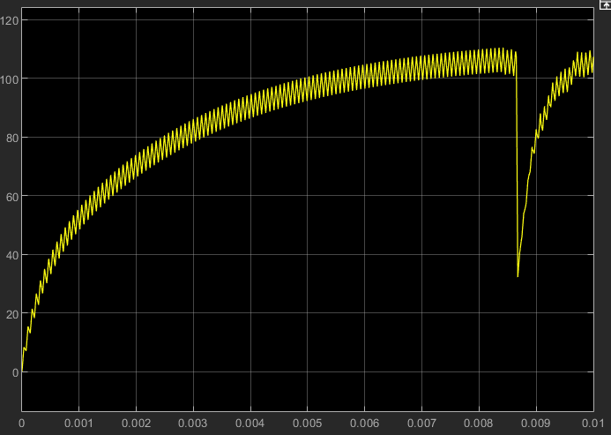

At 13.8Khz graph

IL at 7khz = 58.3 amps

IL at 13.8 = 104.5 amps

IL at 14khz = 68.86 amps

III)

